Conducting Course Evaluations Using Qualtrics
Advantages
- No additional cost (if you already have Qualtrics)
- Easier to administer, create reports, share results than paper evaluations
- Reduces staff workload, data entry errors, money spent on producing paper evaluation forms, turnaround time in receiving summary reports, and archives the data
- Ability to provide unique access links to students, while keeping respondent anonymous
- Ability to send reminders to those who have not yet completed the survey
Disadvantages
- It is not a course evaluation software; using Qualtrics requires that you perform some of the work (e.g. accommodate different evaluation timelines) that a course eval system does automatically
- Can be overwhelming if one person/department is administering course evaluations for the entire institution
- Response rates may be lower than when paper evaluations were used
- Course evaluations are housed within one staff person’s account (can create shared account)
Qualtrics at Claremont Graduate University
- Each academic department is responsible for conducting their own course evaluations.
- The Office of Institutional Effectiveness (OIE) delivers training every semester to department staff responsible for administering course evaluations.
- OIE developed templates for the course evaluation survey, reports, email messages, and email subject lines. Additionally, a query was developed in our SIS to produce the contact lists needed for course evaluations.
- Embedded data is utilized to personalize the course evaluation email invitation (message and subject line), in addition to the survey.
- Staff are encouraged to administer a single course evaluation survey for their entire department when possible (one contact list is produced with all students enrolled in department courses).
Best Practices
- Communicate, communicate, communicate!
  - Staff are encouraged to alert faculty and students about upcoming course evaluations
  - Faculty are encouraged to discuss the importance of course evaluations with students, how they’ve been used in the past, etc.
- It’s everyone’s responsibility to increase response rates
  - Staff are encouraged to provide faculty an update on their response rates at least once
  - Faculty are encouraged to provide dedicated class time to complete course evaluations
Lessons Learned
- Students are busy –it’s the end of the term. If they’re not given the time to complete evaluations in class, they might not complete them at all
- High expectations by faculty: response rates, report turnaround, etc.
- Staff are all at different skill levels with technology; be prepared to teach beyond Qualtrics

COURSE EVALUATION TIMELINE OF EVENTS
Collection Open
Before
After
1 Month Before End of Term
1 Course evaluations are created in Qualtrics
2 Panels are downloaded from PeopleSoft and uploaded into Qualtrics
3 Email and reminder emails are set up
4 Instructors are notified of the dates when the course evaluations will be accessible by students and when students will be receiving emails and reminders
5 Email sent to students by chair/staff a few days prior to the collection opening notifying them that they will be receiving course evaluations emails and the importance of providing responses
3 Weeks Before End of Term
6 Instructors remind students about the online course evaluations and relay the importance of their responses
7 Instructors are given an update on response rates at the end of first week of collection
8 Instructors notify students the date when time will be set aside in class to complete evaluations & remind them to bring laptops, etc.
9 Instructors are given final update on response rates a few days before closure
10 Instructors provide students time in class to complete course evaluations, usually last day of class
End of Term
11 Final response rates are tabulated by course and instructor
12 Individual course evaluation reports are exported from Qualtrics
13 Department or School level course evaluation reports are created
14 Instructor submits grades for classes
15 Course evaluation reports are distributed to instructors and department chairs/deans via web links or Word/PDF exports from Qualtrics

Setting Up a Course Evaluation Template in Qualtrics
Step 1: Create a Contact List Template
- What information do you want to embed in email messages and survey? E.g. Course Description
- What information do you want when creating reports? E.g. unique course identifier
- Qualtrics requires that the uploaded contact list is a CSV file, contains the name of the fields in the first row of the spreadsheet, and an email address is provided for each row (recipient)
Contact List Fields used at CGU (fields in bold are Qualtrics specific)
- Term – embedded so that survey data can be combined with other terms and is used to embed in email message and survey
- Subject – Used to embed in email message and survey, and to create aggregate reports at the Subject level (equivalent to our departments)
- Catalog – Course catalog number is embedded in email message and survey
- ClassNbr – Unique course identifier, allowing to create distinct reports for each course
- Section – Class section can be used in analyzing differences for the same course across sections
- Session – Allows staff to identify when course evaluations should be sent based on the session within the semester
- CourseDescr – Course description is embedded in email message and survey
- InstructorLName – Instructor’s last name is embedded in email message and survey
- InstructorFName – Instructor’s first name is embedded in email message and survey
- StudentID – Unique student identifier used when searching for students in the contact list
- LastName – Student last name can be used as an embedded field in email invitation
- FirstName – Student first name can be used as an embedded field in email invitation
- Email – Student’s campus email address
- ExternalReference – A unique identifier created combing ClassNbr and InstructorLName. Important field if creating a contact list which includes data for multiple courses. Allows you to calculate response rates for each class taught by a specific instructor.
Step 2: Create Survey Template
- Set up a template survey in which you/staff will copy from every time a course evaluation survey is created. Note: It is best practice that new course evaluations are created solely by copying the template as by copying past course evaluations surveys can exclude any updates made to the template and any modifications that may have been made to past surveys and their reports.
- Embedded data is inserted at the top so that no manual entry of information is needed and students can determine which course evaluation they are completing
- Enter survey questions, change response values, and question names (e.g. Q1) as needed
- Set survey as anonymous in Survey Options and make any other necessary adjustments
- Set Survey Flow to capture embedded data from contact list (excluding student information) that you would like to use when creating a report and/or downloading the data
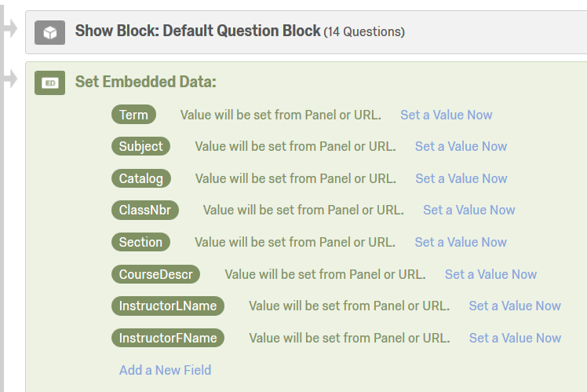

Step 3: Create Survey Report Template
- Once the survey has been set up, navigate to the Reports window
- Modify the Initial Report to what the final report format should look like, e.g. changing the Bar Chart to a Simple Table, removing recode values, hiding embedded data, etc.
- Note: the formatted report will be copied over when a new course evaluation is created from the Survey Template. This saves time in having to format each and every report created.
Step 4: Create and Save Email Subject and Message
- To reduce manual entry, utilize embedded data to craft a subject and email message
- Once crafted, navigate to the Library page (found at the top of the screen), then Messages Library, and click on + New Message
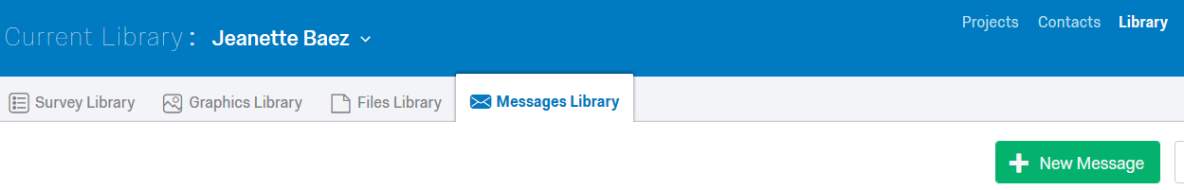
- Create a new message for:
  - Email Subject Messages – what recipients will receive when sent an invitation/reminder
  - Invite Emails – what recipients will receive when first invited to complete evaluations
  - Reminder Emails – what recipients will receive when they’re sent a reminder
- Note: Staff will have to be instructed on how to input these messages only once as they will then access these messages later through the Qualtrics system.
Email Subject Line Template used at CGU
${e://Field/Term} ${e://Field/Subject} ${e://Field/Catalog} Course Evaluation – Professor ${e://Field/InstructorLName}
Invite Email/Reminder Email Template used at CGU
Dear Students,
Each semester the feedback and comments provided in course evaluations are reviewed by the professors, chair, and dean of your department. The information informs curricular and teaching improvements. The time you take to provide detailed, constructive, and candid responses is greatly appreciated and the information is used.
Your responses are anonymous. The online survey system will record that we have received a response from your e-mail address in order to send follow-up reminders, but it does not link your completed questionnaire to any identifying information. Faculty will receive an aggregate summary of evaluation results only after grades have been distributed.
Please take a few minutes to complete this ${l://SurveyLink?d=course evaluation} for ${e://Field/Subject} ${e://Field/Catalog}-${e://Field/Section} "${e://Field/CourseDescr}" taught by Professor ${e://Field/InstructorLName}.
Click on the following link or copy and paste the URL into your internet browser to complete your evaluation:
${l://SurveyURL}
Step 5: Share Survey with Staff and Provide Training
- Provide only Copy privileges to all staff who will administer course evaluations. This prevents anyone from accidently changing the template and it provides a single updated version that staff can rely on.
- Due to changes in positions, responsibilities, and minimal experience with Qualtrics, training should be provided periodically. A manual covering basic instructions should be provided, along with other handouts, such as how to determine response rates, organizing surveys with folders
- At CGU, training is delivered in a series of three one-hour training sessions about a month before the end of every semester:
  - Session 1: Creating the evaluation survey(s) and panel, managing surveys, accessing resources.
  - Session 2: Uploading panels, creating an email distribution, setting reminders, determining response rates
  - Session 3: Creating reports, filtering data, exporting reports, refresh on response rates
Additional nuts and bolts to using Qualtrics:
- Learn everything you can about Qualtrics, keep abreast on latest developments, and experiment. This can positively benefit your course evaluations, but it is also beneficial when helping others troubleshoot issues or even construct new surveys.
- Becoming a Brand Administrator is helpful when surveys need to be transferred from one account to another person’s account and when helping someone troubleshoot an issue (can remotely log into their account).
- Work collaboratively with your IT department to ensure recipients are receiving your survey invitations, e.g. whitelisting Qualtrics servers and setting up an SPF record.
- The easiest way to conduct course evaluations is to create one survey for the term, one contact list for all those enrolled in courses that are to be evaluated, and a single email invitation with reminders. If there is a need to have students in a specific course(s) to receive their email invitation on a certain date and time, an individual contact list must be made for them along with a corresponding email invitation and reminders. Multiple contact lists can be distributed the same survey or one survey can be created for each unique contact list.
- You can combine multiple survey results into one survey by exporting data from the secondary surveys and importing it into a primary survey.
Resources:
- Learn Qualtrics in 5 Steps online tutorial https://www.qualtrics.com/support/survey-platform/getting-started/survey-platform-overview/
- Adding embedded data to your survey and email messages https://www.qualtrics.com/support/survey-platform/survey-module/editing-questions/piped-text/piped-text-overview/#PipingFromAContactListField
- Recoding values https://www.qualtrics.com/support/survey-platform/survey-module/question-options/recode-values/
- Survey Options overview, including details on survey access by invitation only, setting expiration dates, anonymizing responses, etc. https://www.qualtrics.com/support/survey-platform/survey-module/survey-options/survey-options-overview/
- How to include embedded data in your survey results https://www.qualtrics.com/support/survey-platform/survey-module/survey-flow/standard-elements/embedded-data/#SettingValuesFromAContactList
- Filtering results https://www.qualtrics.com/support/survey-platform/reports-module/filtering-results/
- Saving email message and subject line templates in your account library https://www.qualtrics.com/support/survey-platform/account-library/message-library/
- Managing users, including changing survey ownership and accessing user accounts https://www.qualtrics.com/support/survey-platform/sp-administration/managing-users/creating-and-managing-users/
- Determining response rates by downloading mailing history (note: an External reference ID must be created if responses are anonymous to calculate rates by course. See Step 1 for more info): https://www.qualtrics.com/support/survey-platform/distributions/email-distribution/emails/email-distribution-management/#DownloadingTheDistributionHistory

CGU Training Session Outline
Session 1
- Creating the evaluation survey(s)
  - Determining when to do batch and when to do singular evaluations
  - Copying from evaluation template
  - Naming the survey
  - Setting expiration dates (open two weeks prior to finals week)
- Creating a contact list
  - Accessing query in PeopleSoft
  - Searching for query (CC_COURSE_EVAL_ROSTERS)
  - Downloading results
  - Removing first row from results so that headers are on first row
  - Deleting courses (identified by course number) that shouldn’t be evaluated
    - E.g. independent studies, doctoral studies, classes fewer than 5 students, other classes that can’t be evaluated with the survey (internship, field placement), etc.
  - Adding any courses that are listed in another Academic Org (reminding to coordinate with person responsible with the course listed in the other Academic Org)
    - E.g. cross listed courses
  - Saving file as CSV
  - Uploading into Qualtrics
  - Accessing the contact list and viewing member history
- Managing Surveys
  - Manage Folders on the My Surveys tab
  - Creating a new folder
  - Filing surveys
  - Filtering folders on the My Surveys tab
- Accessing Resources
  - Navigating to the Communities in the CGU Portal and to the OIE page
  - Accessing the Course Evaluation Resources folder
  - Pointing out some key resources, such as the Manual and the email template to students

Session 2
- Recap of contact lists and making sure everyone has upload them
- Creating an email distribution
  - Navigating to Distribute Survey, Email Survey
  - Selecting the panel
  - Setting up the custom date and time distribution
  - Replacing the From Qualtrics email address to CGU email address
  - Loading the saved course evaluation message
    - Or showing how to save the course eval message using the template from the OIE community folder
  - Making necessary changes (e.g. survey deadline), if applicable, to the message and resaving
  - Saving the template subject line
  - Schedule mailing
- Setting 2 reminders (one week into the distribution and a few days before survey close)
  - Navigating to the Distribute Survey, Email History
  - Accessing the reminders menu through Actions, Send a Reminder or Thank You
  - Selecting Reminder
  - Loading the saved course evaluation message
    - Or showing how to save the course eval message using the template from the OIE community folder
  - Making necessary changes (e.g. survey deadline), if applicable, to the message and resaving
  - Schedule mailing
  - Set up secondary reminder
- Calculating response rates
  - Navigating to the Distribute Survey, Email History
  - Accessing the mailing history through Actions, Download Mailing History
  - Using the External Reference field and Status field to determine response rates for a particular class and instructor
  - Quick tutorial of pivot tables to calculate response rates

Session 3
- Recap of calculating response rates
- Creating reports
  - Navigating to the View Results tab, View Report, Initial Report
  - Copying the Initial Report and proving specific name to copied report
    - E.g. Fall 2014 TNDY 401 Course Eval- Roberts
  - Applying filter to the copied report
    - Add a filter to this report
    - If Embedded Data is ClassNbr equal to _____
    - Add secondary filter if a course is co-taught with: If Embedded Data is InstructorLName equal to ________
  - Creating additional reports by going back to the Initial Report, Copy, etc.
- Exporting reports
  - How to Export to Word (preferred) and PDF
  - How to access link to an online report using Public Reports

